Name: ____________________________________ Student ID: _________________

BN3402 Bioanalytics for Engineers
Training Module – Western Blotting Data Analysis

INTRODUCTION
To understand how proteins are normally regulated and how this regulation is altered in disease states, it is important to be able to interrogate changes in a protein’s expression, localization and/or function. One classic, affordable and routinely used technique for monitoring changes in protein expression and/or function is western blotting. In this tutorial, you will learn how to interpret western blotting data to analyze experimental results.
Learning Objectives:
1) Use StarCellBio to perform the respective western blot experiments
2) Design and implement experiments in StarCellBio using the appropriate experimental conditions such as primary and secondary antibodies
3) Analyse the western blotting results to determine the level of regulation of Protein X and how mutation has affected its regulation
Question 1

You are studying a protein, Protein X, involved in cell growth in humans. Protein X’s function is to inhibit cell division and its molecular weight is 30 kDa (kilodaltons). You have been provided with an antibody specific for Protein X that can detect both unphosphorylated and phosphorylated forms of the protein.
Proteins are regulated in many different ways. The figure below shows 2 possible modes of regulation.

You will now explore the possibility that Protein X is regulated through changes in its cellular concentration or through phosphorylation. To start with, you know that addition of a specific ligand to the cell’s media in which the cells are cultured causes positive regulation of Protein X. In the absence of this ligand, Protein X is not expressed and is inactive. Addition of this ligand to the liquid media results in an increase on Protein X’s activity, but you do not know if the increase in activity is due to an increase in availability of Protein X and/or increase in its activity.
You are to obtain the relevant western blots through StarCellBio. Ligand status can be – or + indicating the absence or presence of ligand added in the media in which the cells are cultured. The molecular weight in kDa of the proteins in ladder loaded for the western blots is located on the right side of the blots.
For both western blots, indicate the size and number of bands that you would expect for Protein X in the absence and presence of ligand. Assume that when ligand is added to the media, the cells are collected after the same amount of time where Protein X’s activity has been observed to increase substantially. Remember that Protein X’s molecular weight is 30 kDa. Make the following assumption for the indicated western blot below:
- Assume that Protein X’s activity is regulated via its cellular concentration only.
- Assume that Protein X’s activity is regulated at the level of phosphorylation only through the addition of 20 phosphate residues. Each phosphorylation event adds approximately 80 Daltons to the molecular weight of a protein. Assume that an increase in Protein X’s activity is associated with phosphorylation.

 | - Cellular Concentration | - Phosphorylation
Number of Band(s) | 1 | 2
Size of Band(s) (kDa) | 30 | 30, 31.6

Western Blot Results:
- 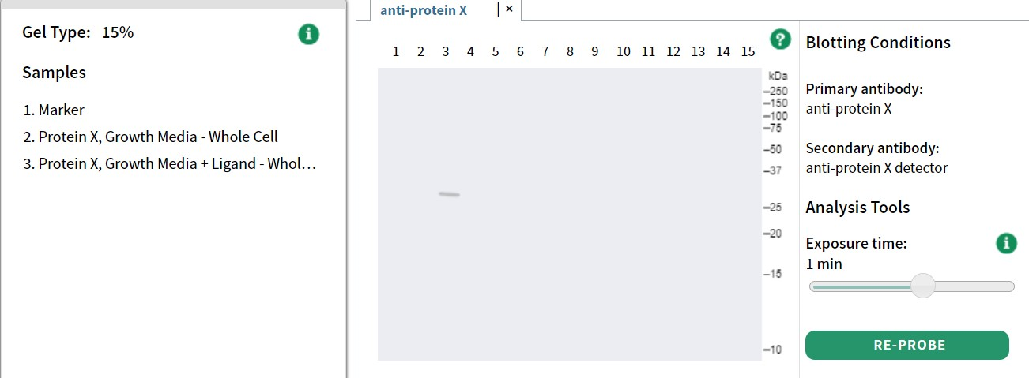
- 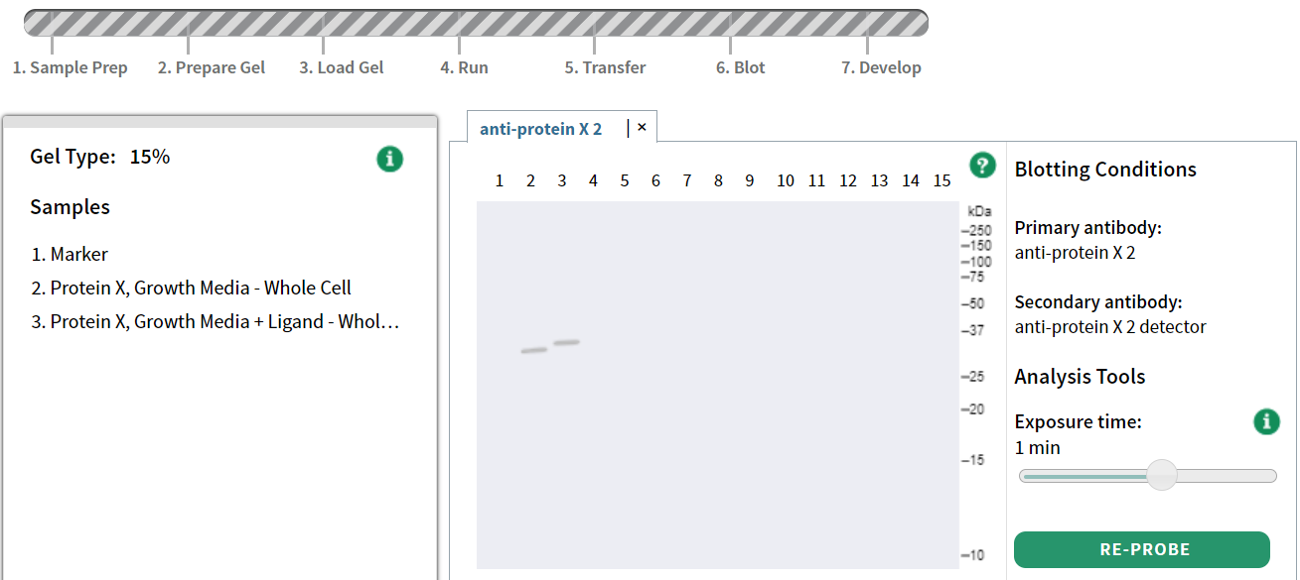

Question 2

If instead of 20 amino acids, only 1 amino acid was phosphorylated on Protein X as a result of ligand addition, it would be very difficult to be able to resolve the unphosphorylated and phosphorylated forms of Protein X on a western blot since the difference between molecular weight would be very small: 80 daltons.
Another way to detect phosphorylation is to use an antibody that either: 1) recognizes amino acids that are typically phosphorylated, for example, antibodies against phosphorylated tyrosines or serines or 2) recognizes a specific amino acid residue within our protein of interest, for example, for Protein X it might be an amino acid that we know is phosphorylated upon addition to ligand.
Indicate the mode of regulation of Protein X, number of band(s) and size of band(s) based on the western blot results in the following scenario: if you use a phospho-specific antibody against Tyr24 in Protein X (amino acid #24 in the protein sequence which is a tyrosine), which we know is phosphorylated after ligand addition.
Mode of Regulation | Phosphorylation
Number of Band(s) | 1
Size of Band(s) (kDa) | ~30

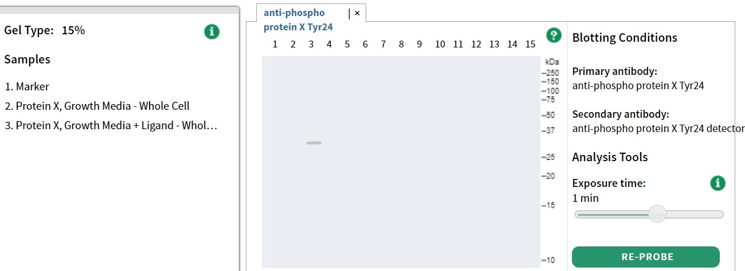

Question 3
In this tutorial, we have considered possible ways in which Protein X could be regulated and how those would affect its concentration and migration on a western blot. In this question, you will be provided with results and asked to make some conclusions based on the data.
You are provided with a mutant cell line, in which a mutant version of Protein X is expressed instead of its wild-type (WT) counterpart. Through StarCellBio, obtain 2 western blot results comparing the mutant with a WT expressing WT Protein X in the absence/presence of ligand. Western blot (a) is to be probed with an antibody that detects both unphosphorylated and phosphorylated forms of Protein X. Western blot (b) is to be probed with a phospho-specific antibody against Protein X’s Tyr24. You can assume that in WT, phosphorylation of Tyr24 is associated with addition of ligand.

Consider the results you have obtained and answer the following questions.
- What is the mode of regulation of wild type Protein X, number of band(s) and size of band(s)? Explain your answer.
 | Wild Type X
Mode of Regulation | Phosphorylation
Number of Band(s) | 1
Size of Band(s) (kDa) | ~30
Wild-type Protein X seems to be regulated at the level of phosphorylation only. Addition of ligand to the growth media does not cause an increase in the overall levels of Protein X, but it does result in Protein X being phosphorylated at Tyr24.
Results for Western Blot
Western Blot (a) 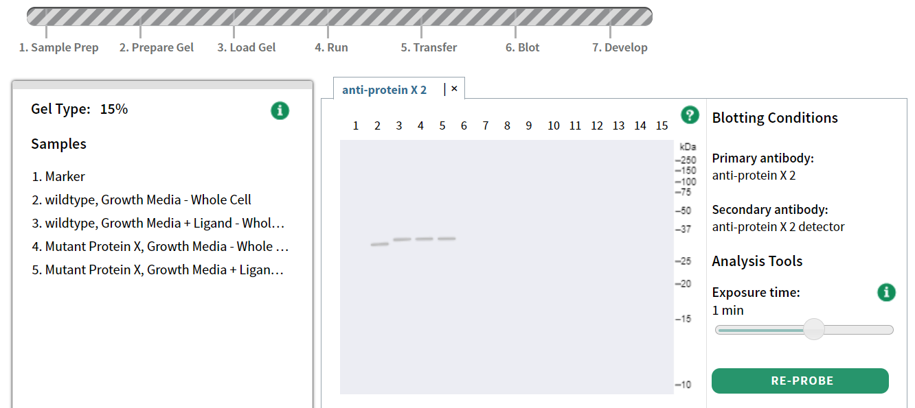
Western Blot (b) 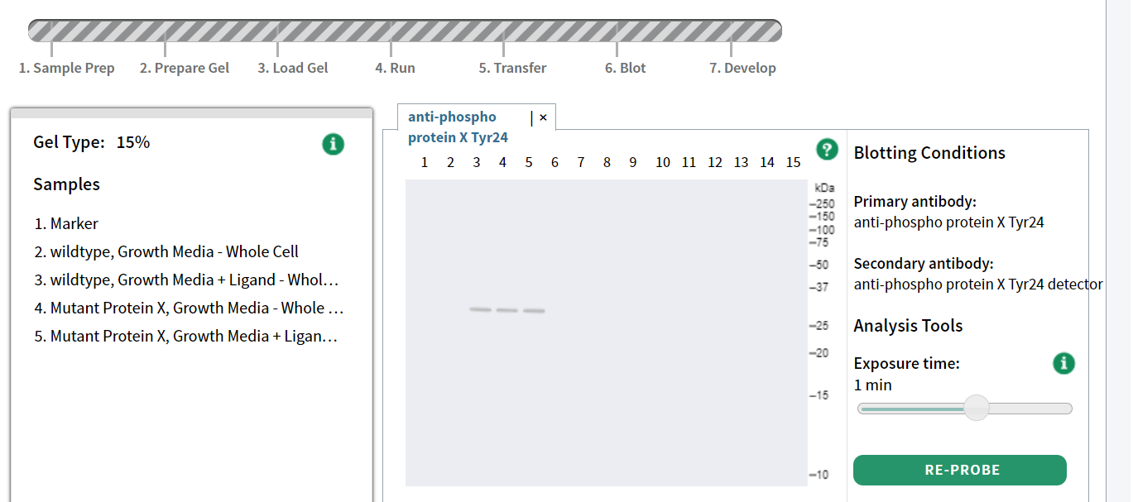

- What can you conclude about how the mutation in Protein X has affected its regulation?
In cells expressing a mutant form of Protein X, mutant Protein X is phosphorylated at Tyr24 in the absence of ligand. Since addition of ligand causes an increase of Protein X’s activity, we can hypothesized that phosphorylation at Tyr24 is associated with activation of Protein X or it is at least a marker for Protein X regulation. If in the absence of ligand, we observe Tyr24 phosphorylation, then these cells constitutively activate Protein X’s activity/Protein X is always activated/permanently activated.

Dalton = a Dalton is defined as 1/12th the mass of a carbon atom. The average amino acid has a molecular weight of approximately 136 Daltons. ² Phosphorylation/dephosphorylation = adding or removal of phosphate residues

